STUDY OF NETWORK COMMANDS

19Z510 – COMPUTER NETWORKS LABORATORY

Anandkumar NS (22Z209)

**BACHELOR** **OF** **ENGINEERING**



Date: 22/07/2024

**DEPARTMENT** **OF** **COMPUTER** **SCIENCE** **ENGINEERING** **PSG** **COLLEGE** **OF** **TECHNOLOGY**

(Autonomous Institution)

**COIMBATORE** **– 641** **004**

1. PING [www.google.com](http://www.google.com)

Verifies IP-level connectivity to another TCP/IP computer by sending Internet Control Message Protocol (ICMP) echo Request messages. The receipt of corresponding echo Reply messages are displayed, along with round-trip times. Ping is the primary TCP/IP command used to troubleshoot connectivity, reachability, and name resolution.

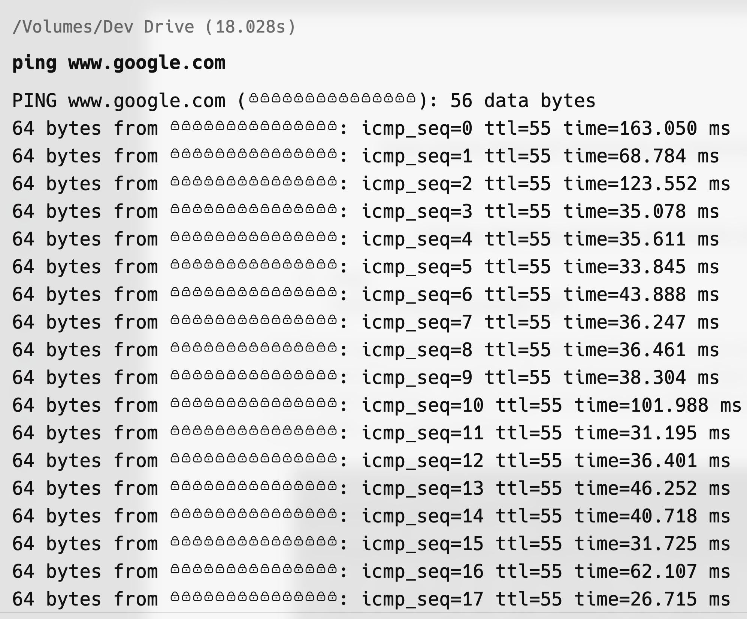

1. NETSTAT

Displays network statistics, including active connections, listening ports, and network protocol statistics. It helps diagnose network-related problems and determine network performance

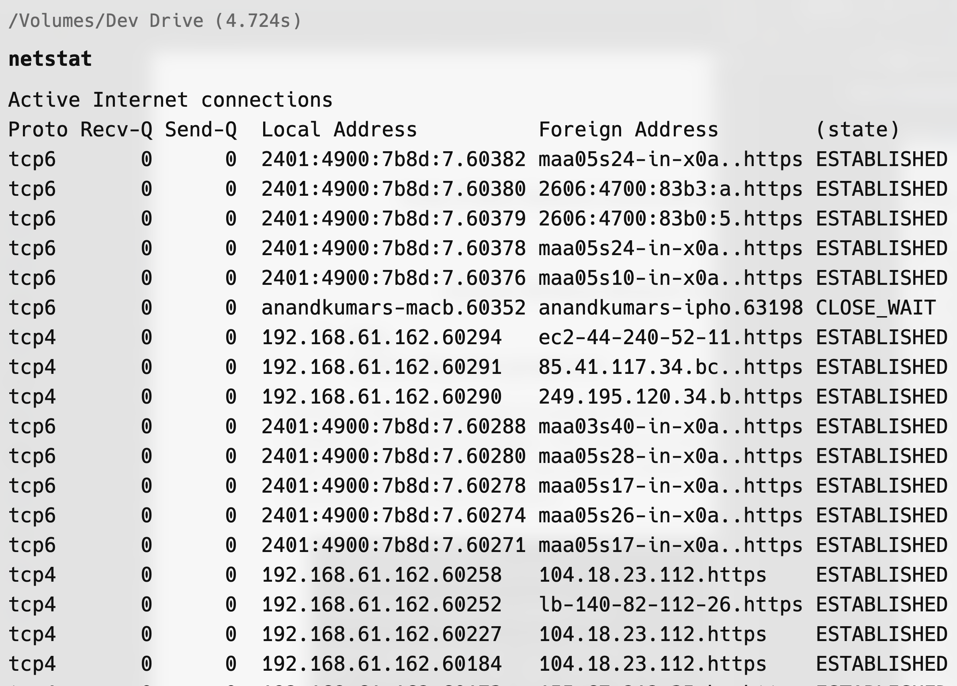

1. HOSTNAME

Displays the name of the current host (computer) on the network. Useful for verifying the device’s hostname.

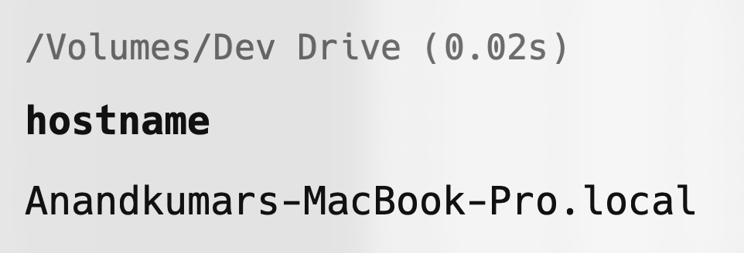

1. IFCONFIG

Configures network interfaces. It is used to view and change the configuration of the network interfaces on the system.

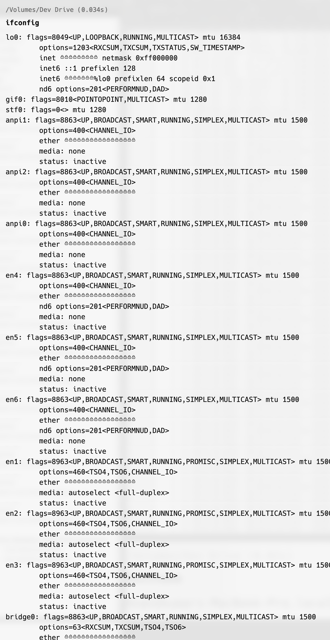

1. NSLOOKUP

Queries the DNS to obtain domain name or IP address mapping. It helps diagnose DNS problems.

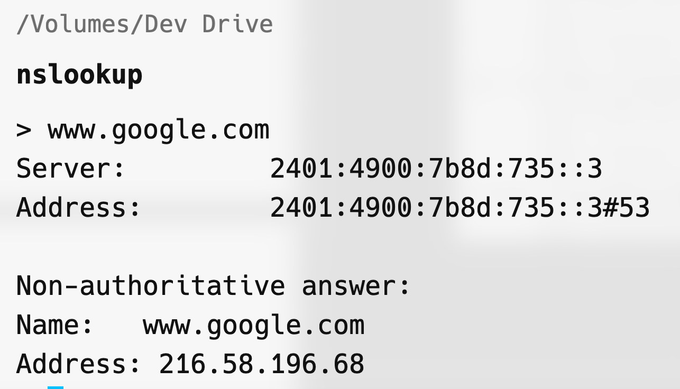

1. NETSTAT -RN

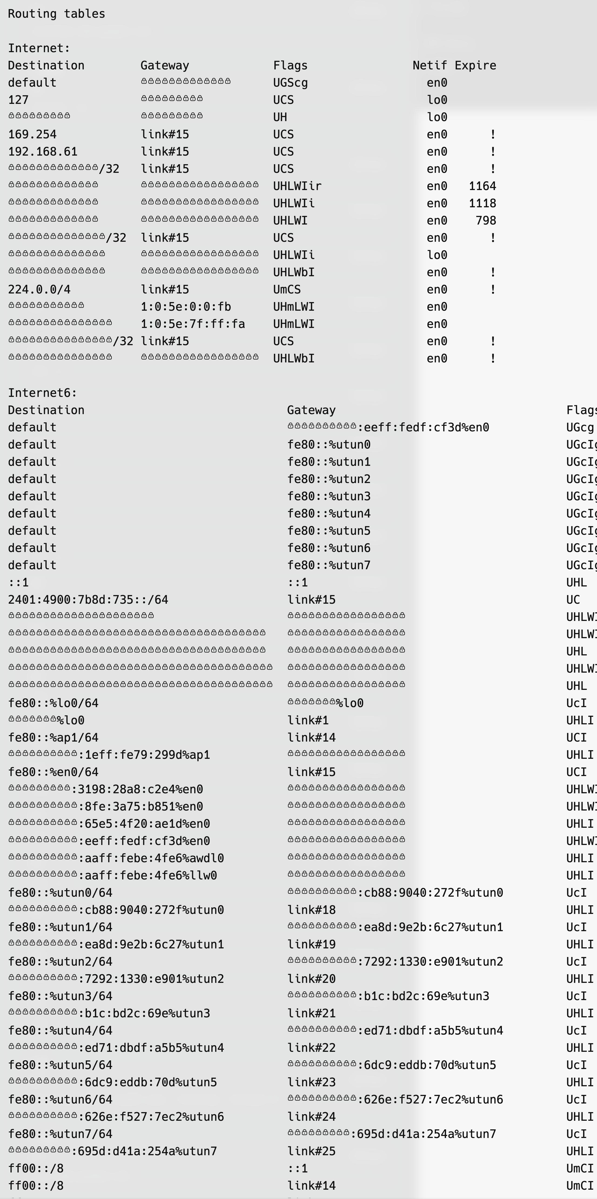

1. ARP -A

Displays and modifies the IP-to-Physical address translation tables used by the Address Resolution Protocol (ARP). It helps diagnose network connectivity issues.

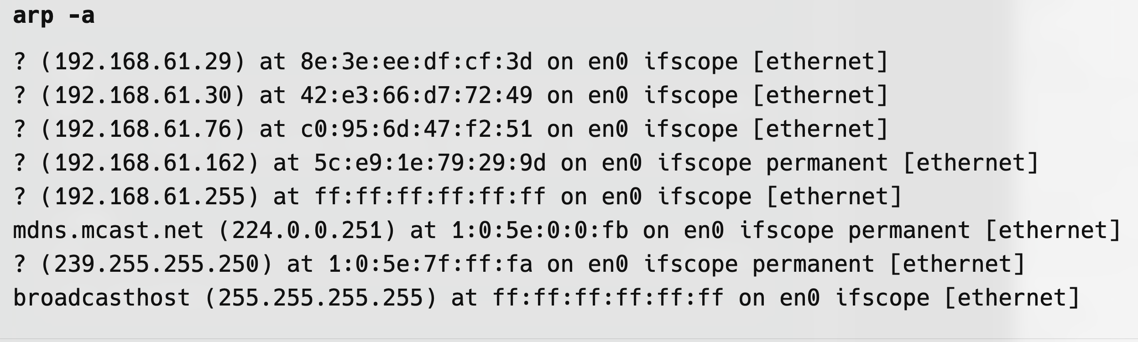

1. HOST [WWW.GOOGLE.COM](http://WWW.GOOGLE.COM)

A simple utility for performing DNS lookups. It converts domain names to IP addresses and vice versa.

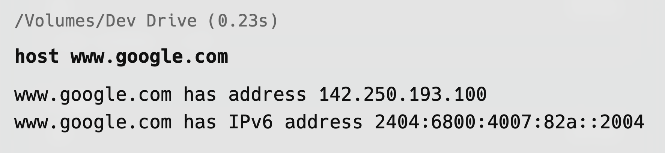

1. DIG [WWW.GOOGLE.COM](http://WWW.GOOGLE.COM)

A DNS lookup utility that provides more detailed information than host and is used to query DNS name servers.

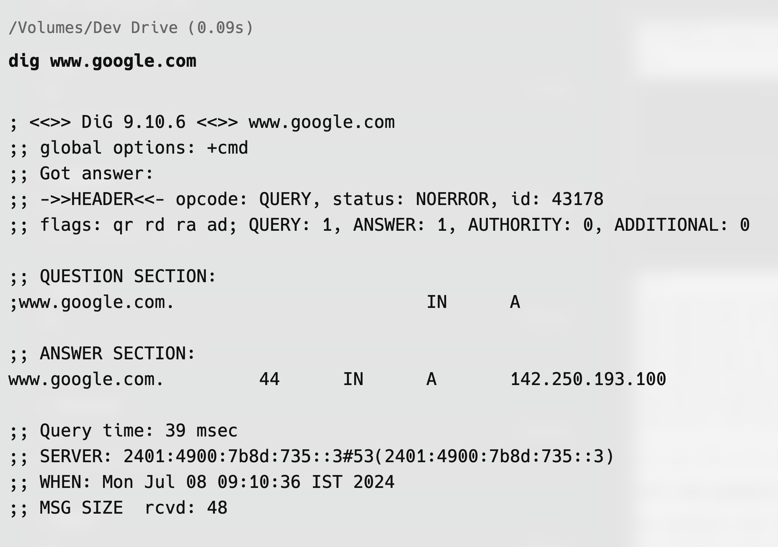

1. CURL [WWW.GOOGLE.COM](http://WWW.GOOGLE.COM)

Transfers data from or to a server using various protocols. It’s a powerful tool for making web requests, such as downloading files or interacting with APIs.

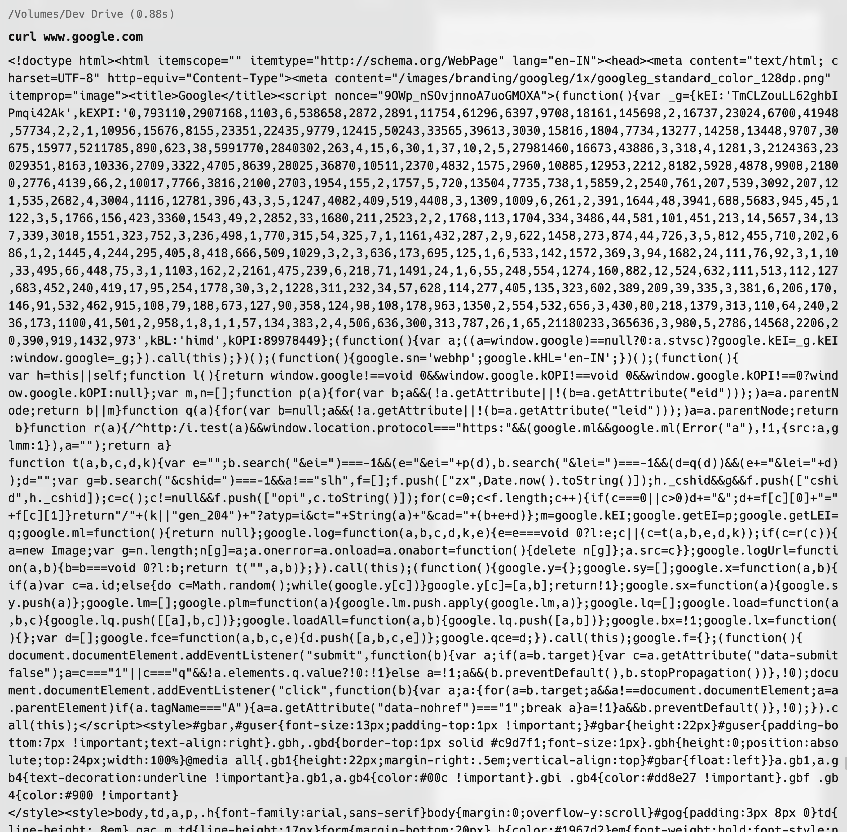

1. SUDO IFCONFIG en0 DOWN

Brings a network interface down. It is used to disable a network interface, stopping it from transmitting and receiving data.

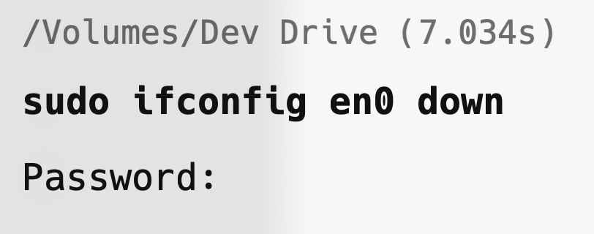

1. SSH USER@HOSTNAME

Connects to a remote host securely over an encrypted SSH connection. It allows secure command execution and file transfers.

1. SCP FILE.TXT USER@HOSTNAME:/path/to/destination

Securely copies files between hosts over an SSH connection. It is used for secure file transfers.

1. SFTP USER@HOSTNAME

Provides an interactive file transfer program, similar to FTP, but over an SSH connection. It allows secure file transfers and management.

1. SUDO TCPDUMP -I en0

Captures and analyzes network packets. It is a powerful command-line packet analyzer used for network diagnostics and troubleshooting.

1. ROUTE PRINT

Syntax: route print

Description: Displays the routing table, gateway routes, and interface list. This command is useful for understanding the paths that data packets take to reach their destination and can help diagnose routing issues.

1. NBSTAT

Syntax: nbtstat -a <IP address>

Description: Displays NetBIOS over TCP/IP statistics, NetBIOS name tables for both the local and remote computers, and the NetBIOS name cache. It helps troubleshoot NetBIOS name resolution issues and view session status.

1. PATHPING

Syntax: pathping www.google.com

Description: Combines the functionality of ping and tracert by identifying the path and computing packet loss at each router over a period of time. It helps diagnose network latency and loss.

1. GETMAC

Syntax: getmac

Description: Displays the MAC address for the network adapters on a system. Useful for identifying the physical address of the device.

1. NETSH

Syntax: netsh interface ip show config

Description: A versatile command-line scripting utility that allows you to display or modify the network configuration of a computer that is currently running. It’s used for network diagnostics and configuration.